Project 1
Anti-HER2 therapies have revolutionized the treatment landscape of breast cancer. Nonetheless, this disease is not yet curable once it has metastasized. Samples from patients previously treated with Trastuzumab can harbor alterations in IRF1. Please, design a project to study the role of IRF1 in mediating resistance, if any, to this anti-HER2 therapy.
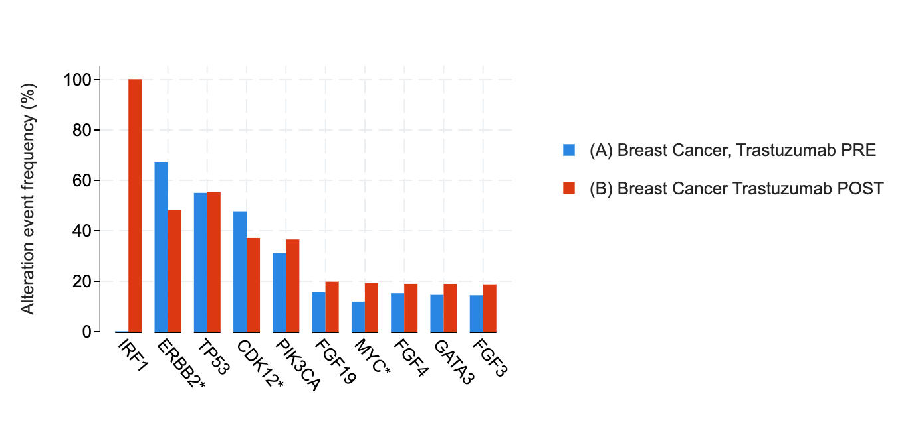
Members:
- Naima Akter
- Carol E. Alata
- Erica Barandica
- Alejandro Casiano-Rosado
- Kennedy Mitchell
- Jadae Watson

