Project 2
Early HR+ breast cancer patients frequently undergo OcoTypeDx testing, a 21-gene expression assay for risk stratification. One of the genes associated with worse prognosis, and therefore, an indication for chemo-hormonotherapy is CD68, a marker of tumor infiltrating macrophages.
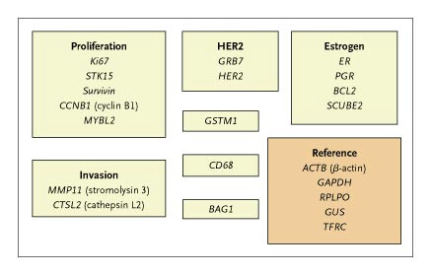
Please, propose a project to study the role of macrophages in early HR+ breast cancer response to chemo-hormonotherapy.

Team CD68 members:
- Sangita Chakraborty
- Erick Gonzalez
- Emilia Ceniceros
- Subyeta Chowdhury
- David Pintor Pinchon

