Project 4
Single-mutant clonal hematopoiesis mutations in ASXL1 frequently appear in smokers. The particles contained in the tobacco smoke are akin to those present in environmental contaminants.
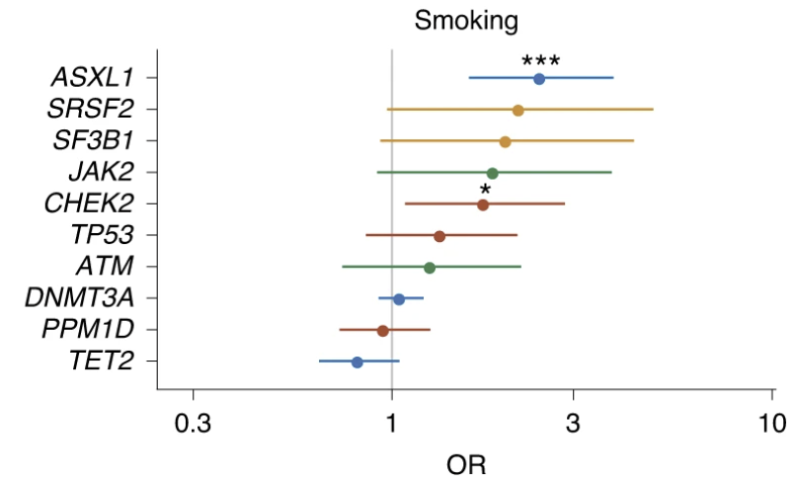
Please, design a project to understand the effect of tobacco smoke on ASXL1 clonal hematopoiesis mutations.
Team ASXL1 members:
- Jahi J. Noel
- Rena Park
- Lucia Martin
- Jayden McDonald
- Valerie Tirado

